# Legal and ethical professional issues

This lecture will deal with legal issues starting with those relating to the University, and leading to how you should discuss legal issues within your team report.

The second part will deal with ethical issues, and we shall take a case study as an example. Again we will look at how ethical issues might be included in your team report, or in your individual reflective statement.

The final part will review chapter 3 as a whole. Remember chapter 3 is the heart of your team report, containing your product development.

## Intellectual Property @ University

* The Third Mission
* Definition of Intellectual Property (IP)
* Types of Intellectual Property
* University’s IP Policy
* Patenting Process & IP Exploitation

## The Third Mission

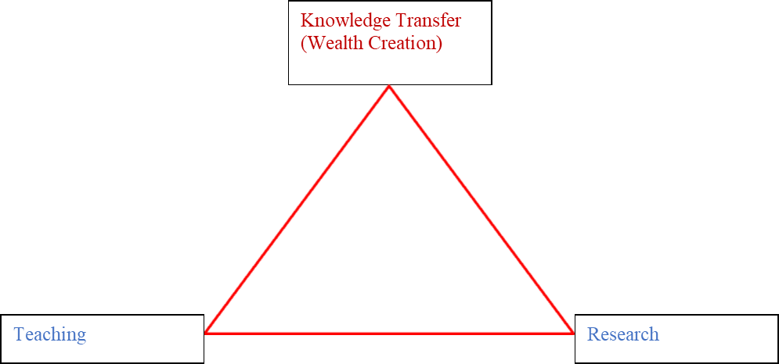

## What is Intellectual Property?

* Intellectual Property is the umbrella term used for various types of intangible property derived from human intellect and expertise i.e. invention, creation
* For example, may be generated as a result of a research project, a piece of consultancy, a collaboration between one or more parties
* Blueprint for new invention, a new design of a product, song lyrics or any new idea that is original and can be identified, bought and sold
* Like Real Property:
  + It can be bought, sold, licensed, exchanged, given away
  + The owner can prevent unauthorized use
* Trademarks
* Service marks
* Copyright
* Patents
* Design rights
* Database rights
* Plant breeders rights
* Know-how
* Information

### Types of Intellectual Property

Copyright

Trademarks

Design Rights

Patents

#### Copyright

* Protects original works (Text, posters, papers, theses, graphics, music, literature, art, software, documents, pictures, sculptural, pantomimes and choreography)
* Automatic (no registration needed)
* Infringement by copying only
* © Anthony Vickers (5 Feb 2015)
* Duration:  life of author + 70 years

#### Trade Marks

* Product or service brands which affect image and reputation
* Signs that distinguish goods / services
* Distinctive words, logo, label, numbers, colour
* Registered/Unregistered
  + ®  - registered mark
  + ™ - indicates proprietary rights
* Duration  -  indefinite

#### Designs

* Protects form and visual appearance of design
* Registered design rights
  + Duration  -  up to 25 years
* Unregistered design rights (similar to copyright)
  + Protects against piracy and counterfeiting
* Duration  -  up to 10 years
  + Automatic claim by putting ‘Design Right’ together with     the date and name of owner on any article

#### Patents

Def: is a registrable monopoly right to the exclusive use of an invention. Requirements for filing a patent

* Be new
  + the invention must never have been disclosed to the public in any way, anywhere in the world, before the date on which an application for a patent is filed
* Involve an inventive step
  + an inventive step that would not be obvious to someone with a good knowledge and experience of the subject
* Be capable of having an industrial application
  + an invention must be capable of being made or used in some way

Duration: 20 years

**Novel??          Obvious??       Application??**

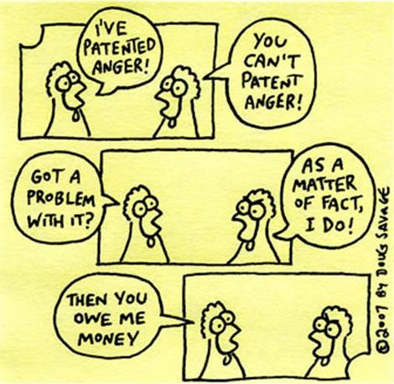

**Inventive step = non-Obvious**

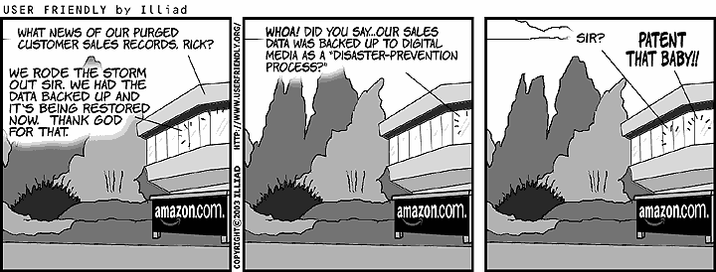

**Patentability – Example**

•   Is it new?

•   Does it involve an inventive step?

Patent Infringement – does 4 include 3?

Energizer vs Gillette

4 blades vs 3 blades

•      Federal Court in Boston ruled against Gillette, [Jan 2004]

•      US Court of Appeals ruled in favour of Gillette (two “second” blades), [April 2005]

•      Out of Court Settlement, [Feb 2006]

##### Example: IP

•         Trademarks could protect names or logos

•         Copyright protects the ringtone and instruction manual. It also protects any website content viewed on it

•         Registered Design could protect shape

•         Patents could protect the working parts, or the process used to make it

### University of Essex on IP Ownership

Staff

* University asserts ownership through contract of employment

Students

* Own their own IP (default) “...all my own work”
* Unless position is governed by a specific contract with other IP terms (with a company or charity etc.)
* Invite to assign to the University of Essex in exchange for a share of future revenues
* Same terms as staff inventors

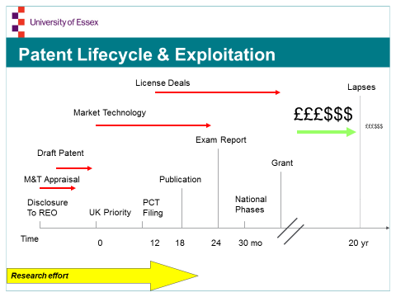

### Commercial Assessment

#### Value of Market

* Size of market
* Growth rate of market

#### Readiness of Opportunity

* Theory –not yet tried?
* Laboratory prototype
* Commercial prototype

#### Potential Return on Investment

* This is over life of the opportunity
* 2x? 10x?

#### Nature of Competition

* Brand new or mature market

#### Competitive Edge of Product

* Sustainable competitive advantage

#### Strength of Proprietary Position

* Original? Protectable? Unique?

### Routes to Market

#### Licensing

* University of Essex negotiates with external Co
* Grants the Co licence to patent
* Negotiations done on tenure/ use/ fees etc.
* Licensing enables University to retain ownership of IPR
* Licensing agreements may be exclusive or non-exclusive

#### Spin-Out Company

* University of Essex arranges Co formation
* Co-owned by Inventor, University (and 3rd party investors if appropriate)
* Can be more flexible and less bureaucratic than University
* Can attract external funding in its own right

#### Joint Venture

* Specific arrangements negotiated with collaborating Cos

#### Sell IP outright

* Lump sum may be considered

### Exit Strategy

* Initial Public Offering
* Sell the Business

## IP Info Sources

* UK Intellectual Property Office (UKIPO)
  + <http://www.ipo.gov.uk/>
* European Patent Office (EPO)
  + <http://www.european-patent-office.org/index.en.php>
* US Patent and Trademark Office
  + <http://www.uspto.gov/>
* The World Intellectual Property Organization (WIPO)
  + <http://www.wipo.int/patentscope/en/>
* Patently-O blog
  + <http://patentlaw.typepad.com/patent/>
  + <http://www.freepatentsonline.com/crazy.html>

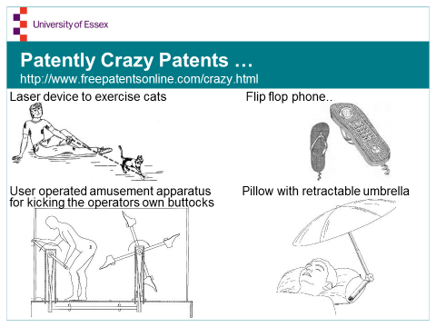

## Ethical Issues

*“The branch of philosophy that defines what is good for the individual and for society and establishes the nature of obligations, or duties, that people owe themselves and one another. In modern society, ethics define how individuals, professionals, and corporations choose to interact with one another.”*

*West's Encyclopedia of American Law*

### Ethical case study – CV Joints

You graduated as a mechanical engineer five years ago, taking a job as a trainee engineer with a major automotive manufacturer. Since you were not happy with this company, you left three years ago to work for Hallmark, a large UK-based engineering consultancy company with several important offices worldwide. Hallmark commonly contract-out their employees to other companies (many consultancies do this). These often involve Hallmark engineers working for many months (sometimes years) at the other company, forming close working relationships with the company's engineers and other staff, and being party to information and data that are confidential to the company.

Soon after you started at Hallmark, they contracted you to work for PartCo Ltd, a large company that designs and manufactures automotive parts (PartCo often contract with Hallmark for engineers when PartCo has important work that requires extra staff). PartCo is a worldwide organisation and does business with most UK, European and Japanese automobile manufacturers. You joined a group doing relatively routine, but highly demanding, work on clarifying the design details for a new range of constant velocity (CV) joints for front-wheel drives. This required computer-based engineering simulations of the parts, testing of prototypes, and final assurance of the products before the designs were released for manufacturing.

Whilst you have been doing this, you got a really good idea for a completely new type of CV joint. You have worked on the idea at week-ends and now believe that it could revolutionise vehicle propulsion. You have continued to work privately on this idea after returning to Hallmark to work on other, non-automotive, jobs.

You have told no-one at either PartCo or Hallmark of your private activities on the new CV joints.

### Ethical Case Study – Questions

1. What intellectual property (IP) is involved here?
2. Who owns it?
3. If you wished to secure and exploit rights to the new CV joint, how would you go about it?
4. Could you justify your actions ethically?

### Professional Bodies and Academies

•      IET (The Institution of Engineering and Technology)

•      BCS (The British Computer Society)

•      RAEng (The Royal Academy of Engineering)

Find out what they say about ethics.

Use the information you find in your context sub-chapter in chapter 3.

Some references are available in the initial reference material folder, chapter 3.